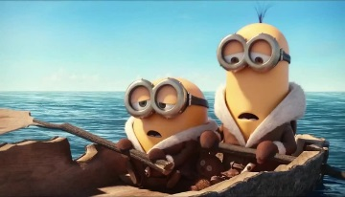
Case of the Shipwrecked Sailors

Three sailors on an oceangoing freighter were cast adrift in a life raft after their ship sank during a storm in the Atlantic Ocean. The ship went down so suddenly that there was no time to send out an
SOS. As far as the three sailors knew, they were the only survivors. They had no food or water in the raft. And they had no fishing gear or other equipment that might be used to get food from the ocean.

After recovering from the shock of the shipwreck, the three sailors began to discuss their situation. Dudley, the ship's navigator, figured that they were at least one thousand miles from land and that the storm had blown them far from where any ships would normally pass. Stephens, the ship's doctor, indicated that without food they could not live longer than 30 days. The only nourishment they could expect was from any rain that might fall from time to time. He noted, however, that if one of the three died before the others, the other two could live a while longer by eating the body of the third.

On the twenty-fifth day, the third sailor, Brooks, who by this time was extremely weak, suggested that they all draw lots and that the loser be killed and eaten by the other two. Both Dudley and Stephens agreed. The next day, lots were drawn and Brooks lost. At this point, Brooks objected and refused to consent However, Dudley and Stephens decided that Brooks would die soon anyway, so they might as well get it over with. After thus agreeing, they killed and ate Brooks.

Five days later, Dudley and Stephens were rescued by a passing ship and brought to port. They explained to authorities what had happened to Brooks. After recovering from their ordeal, the two were placed on trial for murder.

State v. Dudley & Stephens

- Examination of the Ghost of Brooks & Stephens/Dudley
- Closing Statements

Group Discussion

- Did Dudley and Stephens commit murder? Explain.

- Does it matter that Brooks was killed at sea? Why or why not?

- Assume you are in a place with the following law: Any person who deliberately takes the life of another is guilty of murder. Does your answer change based on this definition? Why or why not?

- What purpose would be served by convicting Dudley and Stephens?

- If Dudley and Stephens are convicted, what should their punishment be?

- What is the relationship between law and morality in this case? Was it morally wrong for Dudley and Stephens to kill Brooks? Explain your answer.

- Can an act be legal but immoral? Can an act be morally right but unlawful? Explain.

